Letter Combinations of a Phone number
Problem Statement: Given a string consisting of digits from 2 to 9 (inclusive). Return all possible letter combinations that the number can represent.
Examples
Example 1:
Input: digits = "34"
Output: [ "dg", "dh", "di", "eg", "eh", "ei", "fg", "fh", "fi" ]
Explanation:The 3 is mapped with "def" and 4 is mapped with "ghi".
So all possible combinations by replacing the digits with characters are shown in the output.

Example 2:
Input: digits = "3"
Output: [ "d", "e", "f" ]
Explanation:The 3 is mapped with "def".
Approach
- Create a map that links each digit to its respective set of letters.
- Prepare an empty list to hold all possible letter combinations.
- Define a recursive helper function with three parameters: current index, current combination string, and the result list.
- Check the base case : if the index reaches the end of the input digit string, add the current combination to the results.
- For the digit at the current index, loop through all its mapped letters.
- For each letter, call the helper function again with the next index and the updated combination string.
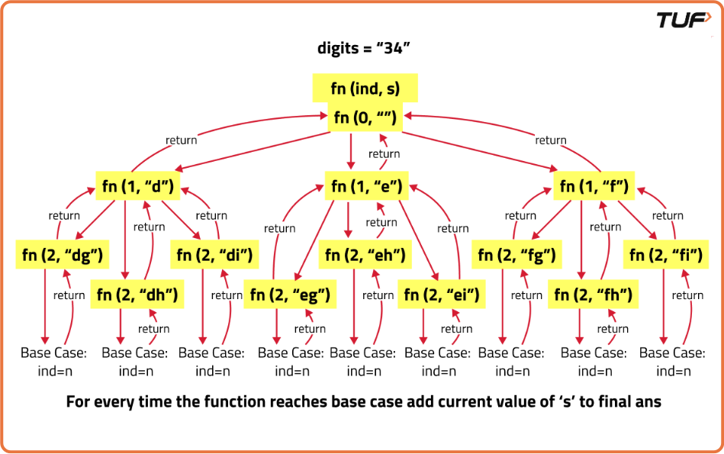
import java.util.ArrayList;
import java.util.List;

class Solution {
private final String[] map;
// Constructor to initialize the mapping of digits to characters
public Solution() {
map = new String[]{"", "", "abc", "def", "ghi", "jkl", "mno", "pqrs", "tuv", "wxyz"};
}

// Recursive helper function to generate combinations
private void helper(String digits, List<String> ans, int index, String current) {
// Base case: if index reaches the end of digits
if (index == digits.length()) {
// Add the current combination to the answer
ans.add(current);
return;
}

// Get characters corresponding to the current digit
String s = map[digits.charAt(index) - '0'];

// Loop through the corresponding characters
for (int i = 0; i < s.length(); i++) {
// Recursively call function with the next index
// Add current character to the string
helper(digits, ans, index + 1, current + s.charAt(i));
}
}

// Function to get all letter combinations for a given digit string
public List<String> letterCombinations(String digits) {
List<String> ans = new ArrayList<>(); // List to store results

// Return empty list if digits string is empty
if (digits.length() == 0) return ans;

// Initiate recursive function
helper(digits, ans, 0, "");
return ans;
}
}
Time Complexity: O(4^N * N), where n is the length of the input digits. This is because each digit can map to up to 4 letters, and there are n digits.
Space Complexity: O(N), where n is the length of the input digits. This is due to the recursion stack depth.

